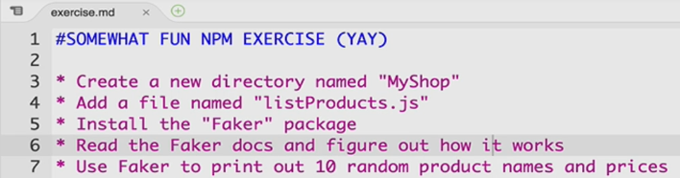

The purpose of this example is to force you to install a package you don’t know yet and quickly learn how to use this package.

Faker is a package that could help us generate fake data.

<https://www.npmjs.com/package/faker>

the result:

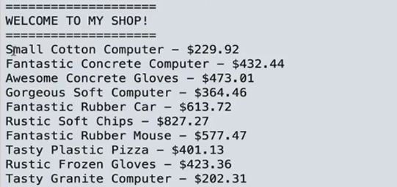

1: install it:

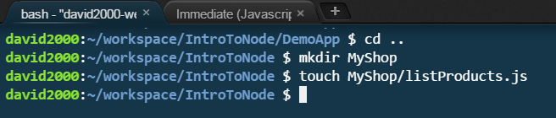

npm install faker

the code:

var faker = require("faker") ;

console.log("===================") ;

console.log("WELCOME TO MY SHOP") ;

console.log("===================") ;

for (var i = 0; i < 10; i++) {

var productName =faker.commerce.productName();;

var price = faker.commerce.price();

console.log(productName + " - $" + price);

}

the output:

